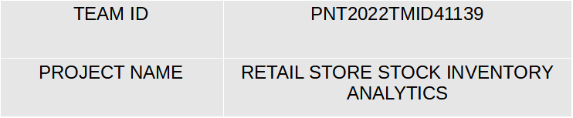
PROJECT DEVELOPMENT PHASE
DELIVERY OF SPRINT-2
SPRINT-1
Data Collection.
Data Preparation.
SPRINT-2
SPRINT-4
Data Exploration.
SPRINT-3
Dashboard Creation.
Report Creation.
Story Creation.

